VTG Employment Application Form
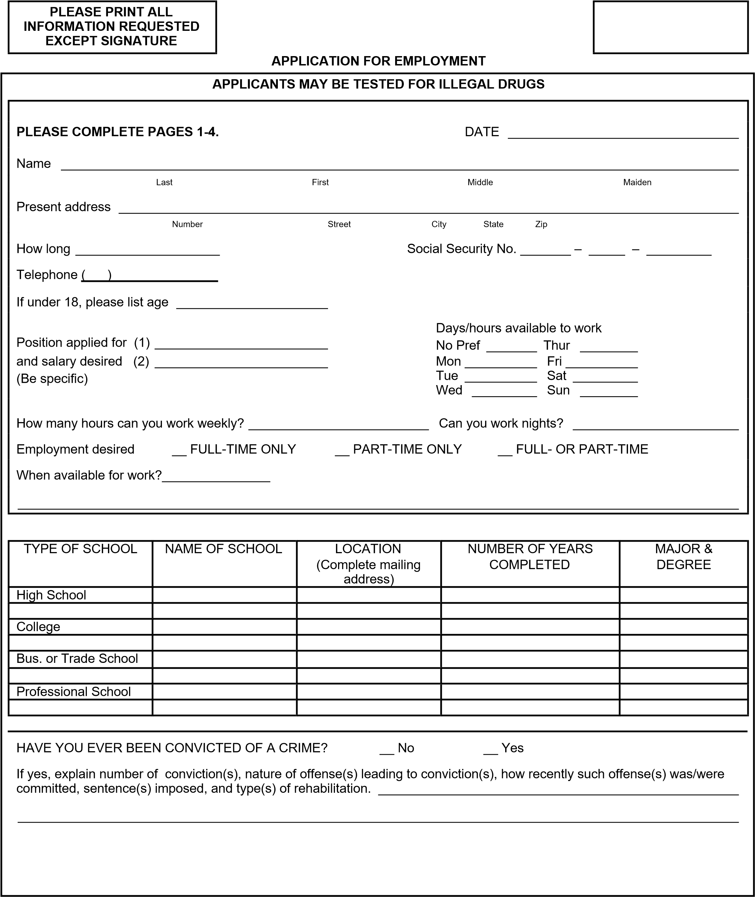
PLEASE PRINT ALL
INFORMATION REQUESTED
EXCEPT SIGNATURE

APPLICATION FOR EMPLOYMENT
DO YOU HAVE A DRIVER’S LICENSE? __ Yes __ No
What is your means of transportation to work? _______________________________________________________________
Driver’s license
number ____________________________ State of issue _______ __ Operator __ Commercial (CDL) __ Chauffeur Expiration date ______________________
Have you had any accidents during the past three years? How many? ___________________
Have you had any moving violations during the past three years? How Many? ___________________
__ Yes  Typing __ No _____ WPM  Personal __ Yes __ PC  Computer __ No __ Mac | OFFICE ONLY |  | Word __ Yes  Processing __ No _____ WPM  _____________________________________________  ______________________________________________
__ Yes
10-key __ No
Other
Skills
Please list two references other than relatives or previous employers.
Name _______________________________________ Name _____________________________________________
Position ______________________________________ Position ___________________________________________
Company _____________________________________ Company __________________________________________
Address ______________________________________ Address ___________________________________________
______________________________________ ___________________________________________
Telephone ( ) Telephone ( )
An application form sometimes makes it difficult for an individual to adequately summarize a complete background. Use the space below to summarize any additional information necessary to describe your full qualifications for the specific position for which you are applying.

PLEASE PRINT ALL
INFORMATION REQUESTED
EXCEPT SIGNATURE

APPLICATION FOR EMPLOYMENT
 | HAVE YOU EVER BEEN IN THE ARMED FORCES?  ARE YOU NOW A MEMBER OF THE NATIONAL GUARD?  Specialty ___________________________________ |  | MILITARY |  |  | __ No  __ Yes __ No  ________________ Discharge Date ______________
__ Yes
Date Entered
 | Work  Experience | Please list your work experience for the past five years beginning with your most recent job held. If you were self-employed, give firm name. Attach additional sheets if necessary.
 | Name of employer Address  City, State, Zip Code  Phone number |  |  | Name of last supervisor |  |  | Employment dates | Pay or salary
 |  |  |  |  |  |  | From  To | Start  Final
 |  |  |  | Your last job title
 | Reason for leaving (be specific)
 | List the jobs you held, duties performed, skills used or learned, advancements or promotions while you worked at this company.
 | Name of employer Address  City, State, Zip Code  Phone number |  |  | Name of last supervisor |  |  | Employment dates | Pay or salary
 |  |  |  |  |  |  | From  To | Start  Final
 |  |  |  | Your Last Job Title
 | Reason for leaving (be specific)
 | List the jobs you held, duties performed, skills used or learned, advancements or promotions while you worked at this company.
PLEASE PRINT ALL
INFORMATION REQUESTED EXCEPT SIGNATURE

APPLICATION FOR EMPLOYMENT
Work experience | Please list your work experience for the past five years beginning with your most recent job held. If you were self-employed, give firm name. Attach additional sheets if necessary.
Name of employer Address  City, State, Zip Code  Phone number |  | Name of last supervisor | Employment dates | Pay or salary
 |  |  | From  To | Start  Final
 |  | Your last job title
Reason for leaving (be specific)
List the jobs you held, duties performed, skills used or learned, advancements or promotions while you worked at this company.
Name of employer  Address  City, State, Zip Code  Phone number |  | Name of last supervisor | Employment dates | Pay or salary
 |  |  | From  To | Start  Final
 |  | Your last job title
Reason for leaving (be specific)
List the jobs you held, duties performed, skills used or learned, advancements or promotions while you worked at this company.
May we contact your present employer? __ Yes __ No
Did you complete this application yourself __ Yes __ No
If not, who did? _______________________________________________________________________________________

Send application to duane@vtstx.com, or fax to 817.385.6497

